Silversquare
DIVERSITY AND INCLUSION CHARTER

Among the Silversquare values that have guided its development, diversity is seen as a source of balance, essential to the company's sustainability, and a creator of value in an ever-changing economic and social context.

In a constantly evolving world, Silversquare is committed to offering workspaces that meet the diverse needs of modern workers. We provide flexible and tailored solutions, designed to adapt not only to professional demands but also to the personal aspirations of each individual.
Our coworking spaces are evolving to become strategic hubs that foster entrepreneurship and community development. This initiative creates a dynamic business community, conducive to the sustainable growth of companies. We thus create the largest community of Belgian entrepreneurs sharing the same values, promoting an inclusive and supportive atmosphere where everyone finds their place.
We encourage the formalization and growth of micro, small, and medium-sized enterprises, while also welcoming large companies into our spaces. This approach promotes a dynamic and inclusive economy, where every player can contribute and thrive.
In this way, we contribute to a sustainable economic model: Silversquare supports innovation by offering an environment that stimulates high levels of economic productivity through diversification, technological improvement, and continuous innovation.

Hence Silversquare is committed to pursuing a permanent social dialogue of quality and adopting the present Charter for Diversity and Inclusion, which formalizes its ambitions, its approach and the means it intends to implement.

With this Charter, Silversquare is in line with the Sustainable Development Goals (SDGs) set by the United Nations, including in particular the target 10.2 aimed at by 2030 to reduce inequality.

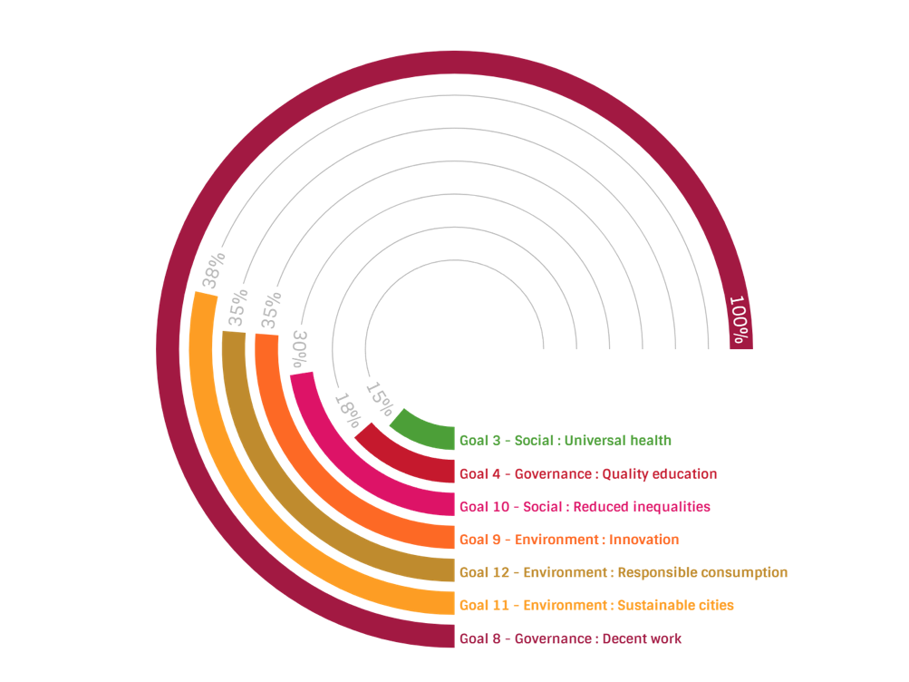
Silversquare contribution to Sustainable Development Goals

Target 10.2 focuses on empowering and promoting the social, economic, and political inclusion of all, regardless of age, sex, disability, race, ethnicity, origin, religion, or economic or other status.

Key Elements of this target :

Inclusivity: The target emphasizes the need for societies to be inclusive, ensuring that no group is marginalized or left behind. This includes addressing systemic barriers that lead to exclusion.
Empowerment: The goal is to empower individuals and communities, ensuring that they have equal opportunities to participate in social, economic, and political life.
Equality of Opportunity: The target seeks to ensure that all individuals have equal access to resources, rights, and opportunities, which is essential for reducing inequalities.

OUR APPROACH

This global approach is based on the development of an inclusive culture that enables everyone, whatever their individuality, to reveal their full potential. This is based on respect and acceptance of differences, enabling everyone to be themselves without being prejudiced.

This inclusive culture:
- Involves creating the conditions for recognition, mutual understanding, trust and integrity;
- Calls for a cross-functional approach that must be reflected in managerial decisions and all personnel management processes;
- Is framed within a perspective of reducing inequalities, whether social, generational or territorial;
- Consists in working both for equality of opportunity favoring the autonomy of disadvantaged populations, and for maintaining the employability of our workers;
- Is based on supporting disadvantaged populations towards autonomy, notably through education, training, social and professional integration.

To be effective, the development of this inclusive culture requires the identification of existing diversity biases within Silversquare as well as the active participation of all members in the implementation of its commitments as well as respect for everyone.

OUR OBJECTIVES
Promoting Equality within the team

Any practice that discriminates against people on grounds such as ethnicity, gender, religion, political opinion, sexual orientation, national ancestry or social origin undermines collective cohesion. For this reason, Silversquare has set itself three objectives to combat discrimination while promoting skills and equaĺ opportunities:

- Optimize recruitment to encourage a diversity of applicants. This requires in particular the implementation of all measures to combat self-censorship and focus recruitment processes on skills. It involves appropriate training for managers and recruiters, and possibly the signing of partnerships with training institutions;

- Pay fairly, to ensure that for equal skills, seniority and positions, salaries respect the principle of equity (in line with ILO Convention 100 on equal remuneration). The achievement of this objective relies in particular on the effective implementation of the principle of "equal pay for equal work" through appropriate compensation transparency mechanisms;

- Promote equitably to ensure that everyone's career development is in line with their aptitudes and aspirations. To achieve this objective, all workers must be made aware of the need to combat stereotypes, and the "non-discrimination" theme must be integrated into all management training courses.

Promoting Non-Discrimination within the members

Any practice that discriminates against people on grounds such as ethnicity, gender, religion, political opinion, sexual orientation, national ancestry or social origin undermines collective cohesion. For this reason, Silversquare invites its members:

If you witness or experience any behavior that violates our principles of non-discrimination, we strongly encourage you to reach out to our Diversity and Inclusion Officer immediately. Your feedback is crucial in helping us maintain a respectful and equitable environment for everyone. Please rest assured that your concerns will be handled with the utmost confidentiality and seriousness.
-> diversity@silversquare.eu

Upholding Inclusivity in our events

We are committed to upholding the principles of non-discrimination in all aspects of our co-working space, including the events we organize. We will be vigilant in ensuring that our speakers and partners reflect the diversity we value so highly. By doing so, we aim to create inclusive events that represent and respect the varied perspectives within our community.

